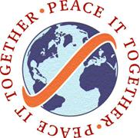

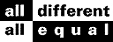 MINORITIES OF ISRAEL

( M.o.I )

A non profit organization for the service of the Community
P.O.Box 578, Kfar Vradim, Israel, 25147
Tel: +972 4 9997186 Mobile: +972 54 4626944
Fax: +972 57 7976527

Email: danwoll@smile.net.il


CALL FOR PARTNERS
(Euro Med Youth Exchange)
Project: Connected Vessels (Water – past, present and future)
Application Date: November 1, 2008
Host Organization: Israel Association for Immigrant Children
Place: North and Central Israel
Duration: 7 days
Activity: Mid 2009
Quantity: 6 countries x 4 participants + group leader
Age: participants 15 to 18; Group leader no age limit
Specification: Youth from minority groups/youth at risk
: Environment conscience
: Basic English
: Gender Balance

Project Description: Youth will travel in Israel visiting different sites where water has
played or is playing an important factor in the lives of the community.
Workshops will be held on the need to protect the purity and conserve
water and the effect water has played on their history and culture.
Different cultures will be visited and examined.
Activities will be planned for activities the participants will carry out
on their return home to increase public awareness on the need to
conserve water.

Cost: Advanced planning meeting – no cost
Activity – 30% of travel cost (including visas and taxes)
Insurance

